Supplementary Material
The combination of polyvinyl alcohol and silicone rubber enhances pervaporation membrane performance
Wilfredo Yave* and Luigi Leva
Research and Development Department, DeltaMem AG, Sandweg 52, 4123 Allschwil, Switzerland

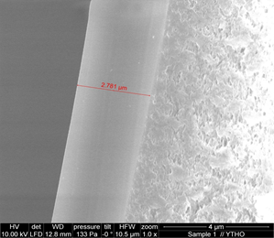a) 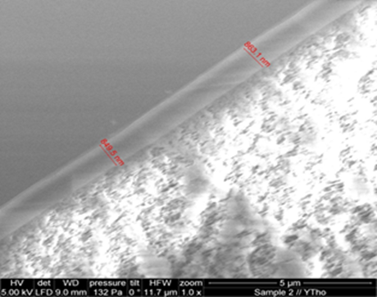b)
Fig. S1 Comparison of membrane thickness between the standard commercial PERVAPTM 4100 (a) and the thin PVA membrane (b)

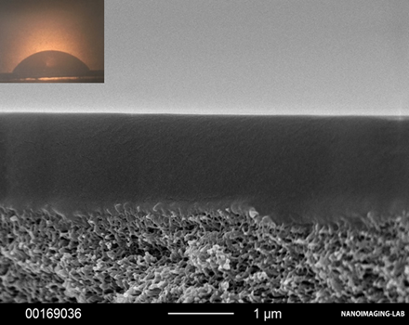a) 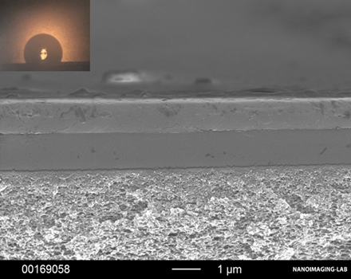b)
Fig. S2 Cross-section of membranes and water drop shape to differentiate the hydrophilicity between single PVA layer (a) and the PVA/silicone multilayer membrane (b)
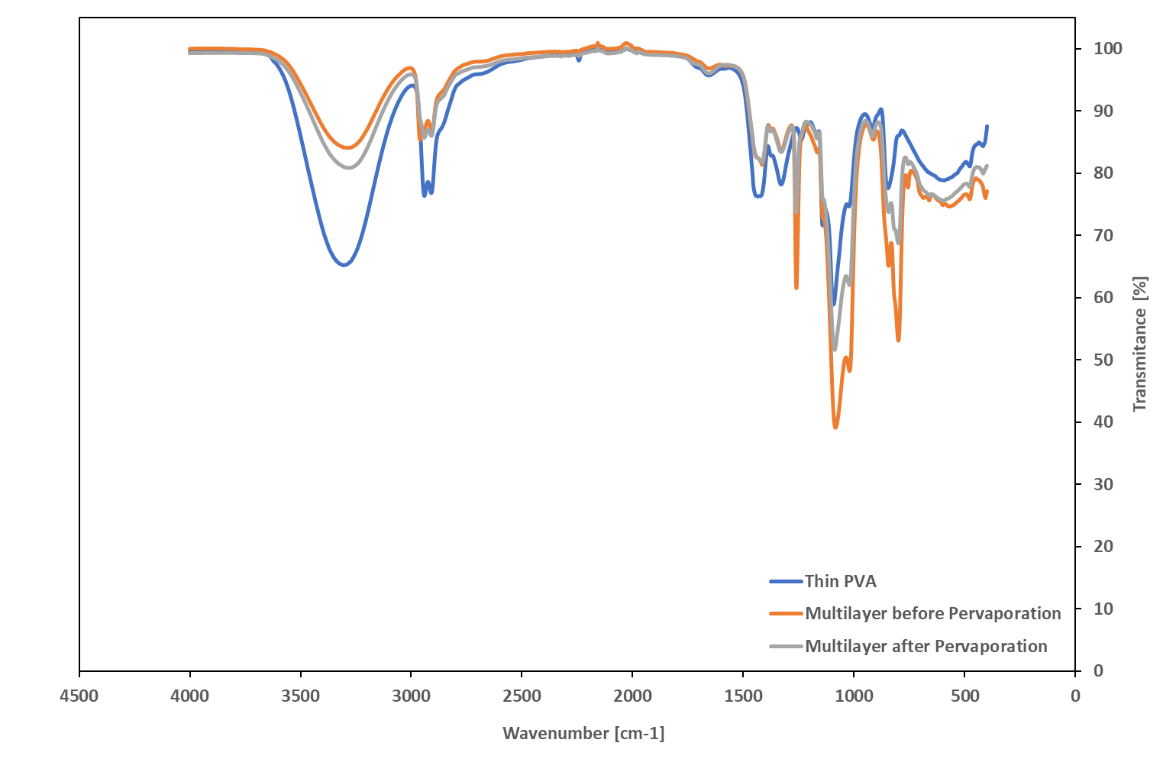
Fig. S3 ATR-FTIR spectra of the thin PVA layer on PAN and PVA/silicone multilayer membrane before and after pervaporation.
As seen, all characteristic peaks of PVA are seen in all samples, it is because the silicone layer is <1000nm in the multilayer membrane (typical depth of penetration in ATR ranges from about 500nm to about 5000nm). Nevertheless, two characteristic peaks corresponding to silicone rubber at 1260 cm-1 (CH3) and 800 cm-1 (Si-C) are clearly observed in the multilayer samples, those peaks can not be seen in the thin PVA sample. All other peaks of silicone rubber are overlapping with those of PVA, and thus, they cannot be distinguished.

To prove that silicone membranes are not selective to ethanol, we have tested the commercial silicone rubber membrane (PERVAPTM 4060). The pervaporation tests showed that the permeation of water molecules through this membrane do not depend on the volatile organic compound (VOC) type at low concentration in the feed, i.e., the water flux was the same for different VOC mixtures (Fig. S4). The water flux corresponding to the tests with pure water (purple data) is also the same to those obtained with other mixtures.
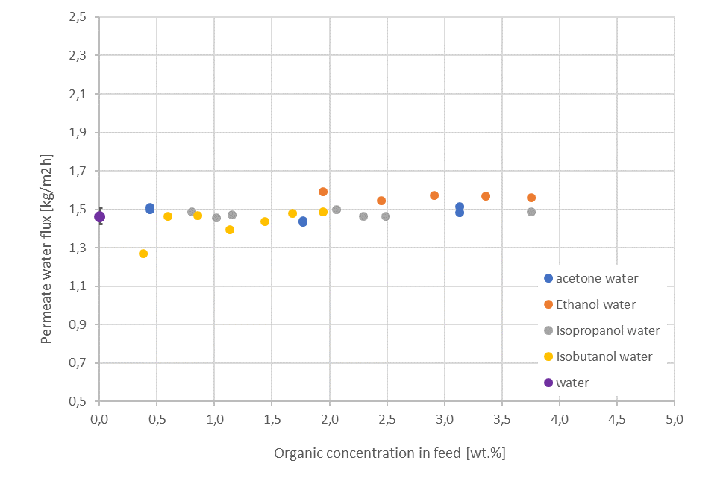
Fig. S4 Permeate water flux through silicone rubber membrane (PERVAPTM 4060) with different organic mixtures as feed, at 60°C and permeate pressure of 10mbar
Rozicka et al [J. Membr. Sci. 453 (2014) 108–118] reported similar membrane behavior and concluded that silicone rubber membrane is not selective for acetone and ethanol.
As the silicone membrane is slightly swollen by the organic compound due to its nature, we suggest that the water molecules permeate freely due to the absence or negligible interactions with the hydrophobic membrane (confirmed recently by Bian et al, Macromol. Rapid Commun, 2021, 42, 2000682), therefore we would expect that the permeability of water is constant over the whole concentration range.
Watson and Baron investigated the behavior of water in poly(dimethyl siloxane) [J. Membr. Sci. 110 (1996) 47-57], their results suggested that the diffusion coefficient of water is nearly constant over a wide range of activity, and the amount of mobile water molecules is solely thermally determined. Following that line, our experimental observations confirm that the water permeation through silicone rubber membrane seems to be solely thermally controlled.
To confirm that the water permeation is not dependent on feed organic concentration, the water permeation has been measured for ethanol/water mixture within the typical range of concentration for industrial dehydration processes. The results are shown in Fig. S5, in which the water permeance values and water/ethanol selectivity are plotted as a function of feed water concentration.
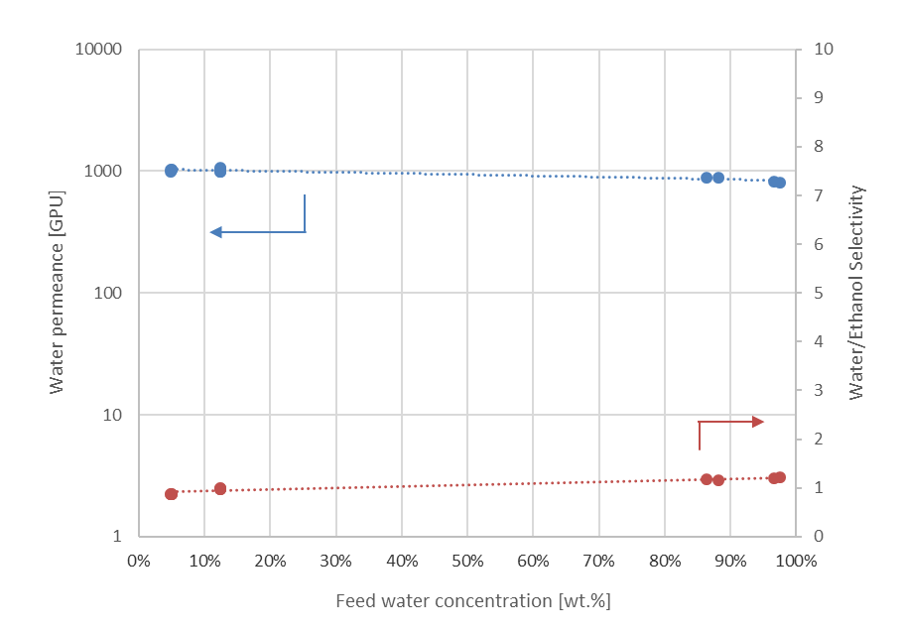
Fig. S5 Water permeance and water/ethanol selectivity for PERVAPTM 4060 as a function of feed water concentration, at 60°C and permeate pressure of 10mbar
The results confirm that silicone rubber membranes like PERVAPTM 4060 are not selective to ethanol, the water/ethanol selectivity is around 1 (or even slightly higher) and the water permeance is almost constant.
The following equations are used for flux, permeance, selectivity and rejection calculation:
Flux: $J_{i}=\frac{m_{i}}{A t}$ (1)
Permeance: $\left(\frac{P_{i}}{l}\right)=\frac{J_{i}}{x_{i}γ_{i}p_{i}^{sat}-y_{i}p^{p}}$ (2)
Selectivity: $α_{ij}=\frac{\left(P_{i}/l\right)}{\left(P_{j}/l\right)}$ (3)
Rejection: $R=\frac{\left(C_{f}-C_{P}\right)}{C_{f}}100\%$ (4)
Where J_{i} represents the flux of component “i”, m_{i} the mass of collected permeate, A the membrane area, t the time for collecting the permeate sample, P_{i} permeability, l the thickness of membrane, x_{i} the concentration in the feed in fraction, γ_{i} the activity coefficient, p^{sat}_{i} the saturated pressure, y_{i} the concentration of permeate in fraction, p^{p} the permeate pressure, α_{ij} the selectivity, R the rejection, c_{f} the feed concentration and c_{p} the permeate concentration.

Fig. S6 presents pictures of wetting tests to visualize the nature and feature of the membrane surface. Fig. S6 a) shows small droplets of water on the thin and less cross-linked PVA membrane and on the multilayer membrane. Fig. S6 b) shows that the thin PVA layer absorbs hot water (left side), then with the help a of spatula, the swollen PVA layer can be easily removed (middle and right side). Fig. S6 c) shows the hot water (big drop) on the multilayer membrane. Here, the protective layer (silicone rubber) rejects the liquid water (left side) and with the spatula does not remove anything, and after few hours, the water evaporates, and the film is intact.

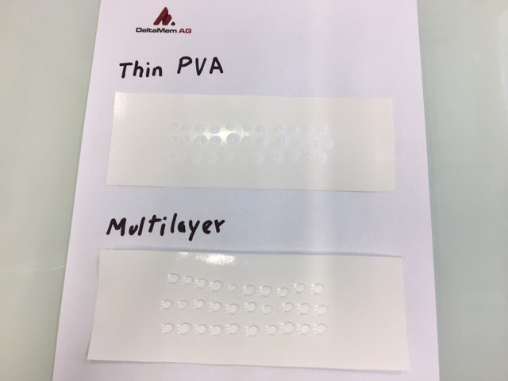 a)
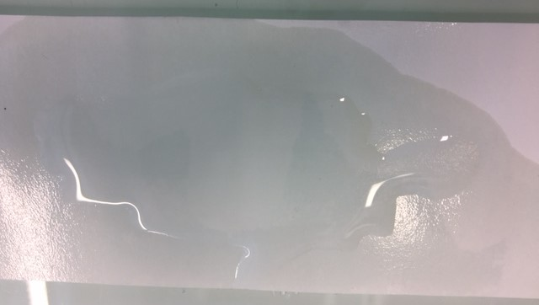 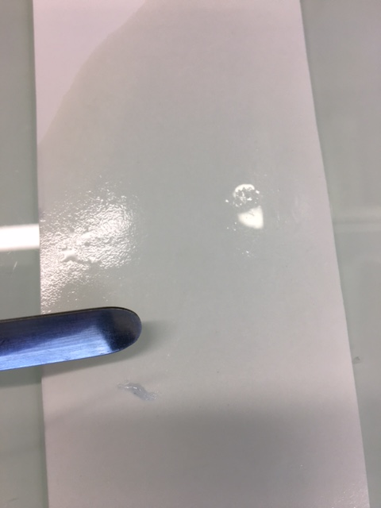 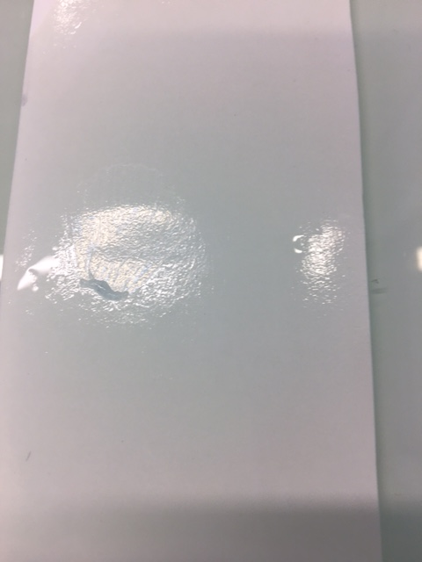 b)
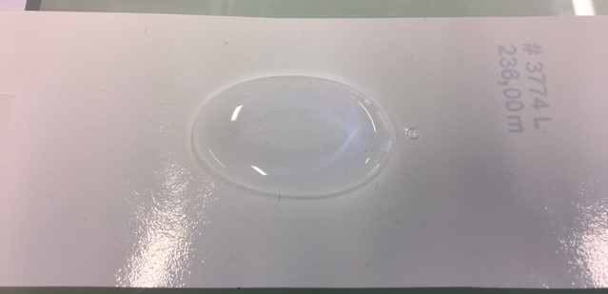 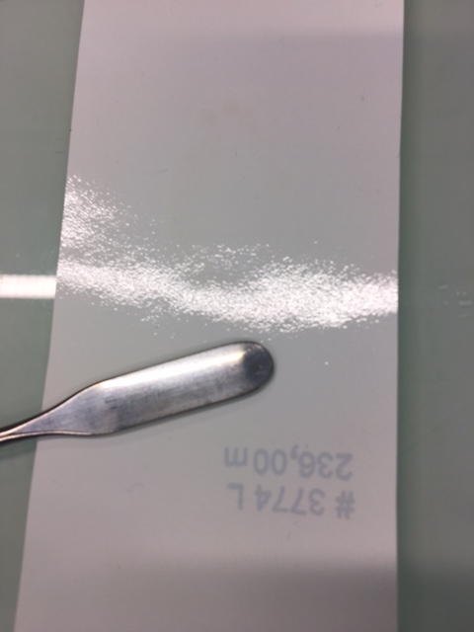 c)
Fig. S6 Membrane samples in contact with water: a) small droplets of water on membrane surface, b) hot water on the thin and less cross-linked PVA membrane, and c) hot water on the new multilayer membrane
Table S1. Comparison of membranes from PVA for desalination by pervaporation at 50-70°C
Membrane type | Salt concentration  [wt.%] | Water flux  [kg/m2h] | Rejection  [%] | Reference
PVA/MA  PVA/MWCNT  PVA/C-MWCNT  PVA/C-MWCNT/MA  GO/PAN  Chitosan/GO  PEI/GO/LbL  PVA/PMDA  Silica/PVA  PVA  Multilayer Membrane | 3.5  3.5  3.5  3.5  3.5  1.0  2  3.5  5  0-10.0 | 8.5  15.8  21.7  11.9  14.3  16.2  8.4  10-16  10.6  6.6  10-11.5 | 92  85  95  99  >99  >99  >99  >99  >99  >99  >99.9 | J. Membr. Sci.  579 (2019) 40  J. Mater. Chem. A  3 (2015) 5140  Desalination  438 (2018)83  Sep. Purif. Technol.  234 (2020) 116077  Petrol. Sci.  15 (2018) 146  J. Environ. Chem. Eng  9 (2021)106327  Sep. Purif. Technol.  290 (2022)120820  This work

